|  |  |
| --- | --- |
|  | **DEPARTMENT OF COMPUTER ENGINEERING** |

**Experiment No. 07**

|  |  |
| --- | --- |
| Semester | B.E. Semester VII – Computer Engineering |
| Subject | Blockchain Lab (CSDL7022) |
| Subject Professor In-charge | Prof. Swapnil S. Sonawane |
| Academic Year | 2024-25 |

|  |  |
| --- | --- |
| Student Name | Deep Salunkhe |
| Roll Number | 21102A0014 |

**Title: Integrating Metamask With DApp**

**Theory:**

MetaMask is a cryptocurrency wallet and browser extension that enables users to manage Ethereum-based assets and interact with decentralized applications (dApps) seamlessly.

**Key Features:**

1. Wallet Functionality:Allows users to create, import, and manage Ethereum wallets securely.
2. Transaction Management:Users can send and receive ETH and tokens, with options to customize gas fees for transactions.
3. dApp Integration:Provides a bridge to interact with dApps directly through the browser, allowing users to engage with smart contracts easily.

**User Interface:**

MetaMask provides a user-friendly interface that allows users to view their account balances, transaction history, and manage assets without needing deep technical knowledge.

**Connecting to dApps:**

When visiting a dApp, MetaMask prompts users to connect their wallet, enabling interaction with smart contracts. This includes sending transactions and querying contract data.

**Security Features:**

* Users control their private keys, and MetaMask encrypts them locally. It supports hardware wallets for enhanced security.
* Users receive notifications for transaction requests, ensuring they can review actions before approval.

**Network Switching:**

MetaMask allows users to switch between different Ethereum networks (mainnet, testnets like Sepolia) and custom networks, facilitating development and testing.

**Smart Contract (DApp):**

// SPDX-License-Identifier: MIT

contract TodoList {

struct Todo {

string text;

bool isDone;

}

Todo[] private todos;

function addTodo(string memory _text) public {

todos.push(Todo(_text,false));

}

function removeTodo(uint _index) public {

todos[_index] = todos[todos.length-1];

todos.pop();

}

function getAllTodos() public view returns(Todo[] memory ){

return todos;

}

function completeTodo(uint _index) public {

todos[_index].isDone = true;

}

function unCompleteTodo(uint _index ) public {

todos[_index].isDone = false;

}

}

**Output:**

Before Deploying and Interacting With Smart Contracts

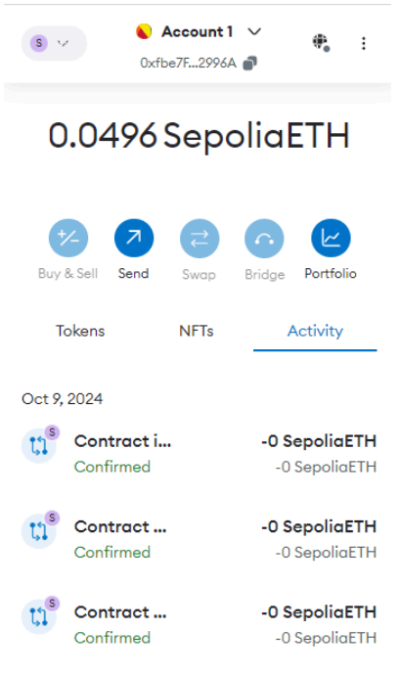

After Deploying and Interacting With Smart Contracts

